The Reactivity Series

Experiment 1

Hypothesis: I predict that in the test tubes with transition metals in will all stay the same with some small bubbles. However the test-tubes with metals in them i predict that many bubbles will be formed and the metals will be corroded.

Mg + HCl → MgHCl
Zn + HCl → ZnHCl
Fe + HCl → FeHCl
Sn + HCl → SnHCl
Cu + HCl → CuHCl

Equipment: 5 test-tubes + rack
dilute hydrochloric acid
Mg, Zn, Fe, Sn and Cu
sand-paper
a beaker

Method:

Spep one: Take small pieces of the following metals: Magnesium, Zink, Iron, Tin and Copper.

Step two: Clean all the metals with sand paper. Be careful to only rubb a little bit with the sandpaper.

Step three: Put a piece of the different metals in seperate test-tubes.

Step four: Pour enough Hydrochloric acid in the test-tubs to cover the metals.

Step four: Observe your results, document them in a table and try to rate the process from 1 to 5 depending on how violent the reaction is.

Step six: If you get poor results try heating the test-tubes in a beaker with hot water.

Results:

The results we have seen from this experiment are as following:

Zn + HCL
Zink + HCL

When we mixed Zink and HCL together a reaction started to take place immediately after we put the Zink in the test-tube. The Zink started dissolving.
We the heated zink. This sped up the process and we saw small pieces of Zink floating in the test-tube

Mg + HCL
Magnesium + HCL

When we mixed Magnesium with HCL we saw a very violent reaction. The magnesium piece had dissolved in less than 45 seconds.
We did not heat the magnesium since there was no visable Magnesium left.

Cu + HCL
Copper + HCL

When we mixed copper with HCL we saw no reaction at all. We looked as hard as we could but nothing could be seen. We even tryed heating it, however nothing happened.

Sn + HCL
Tin+ HCL

Tin was much like Copper we saw only few bubbles. Even when heated, we saw only few bubbles.

Fe + HCL
Iron + HCL

We saw very few bubbles here too however when we heated it the piece of Tin started dissolving.

Here comes a list of the metals that reacted the most. From one to five:

- Magnesium
- Zink
- Iron
- Tin
- Copper

Experiment 2

Hypothesis: I predict that the metal salts will loose their color when put together with the metals. I also predict that the more the metal dissolves the more the color of the salts will change. I did not manage to write chemical equations since I have NO idea of what will happen.

Equipment: 8 test-tubes + rack
Cu, Zn, Fe, Al, Ag
AgNO3, CuSO4, ZnSO4

Method:

Step 1: Place a piece of each metal in different beakers.

Step 2: Pour just enough salt solution to cover the metal pieces.

Step 5: Test the following combinations:

Aluminium + Copper sulphate
Iron + Copper sulphate
Zinc + Copper sulphate
Silver + Copper sulphate
Copper + Silver nitrate
Zinc + Silver nitrate
Copper + Zinc sulphate
Silver + Zinc sulphate

Step 4: Observe and document all your results. Leave the test-tubes for a while and document again.

Results:

AgNO3

Cu + AgNO3

When we mixed copper with silver nitrate the Copper turned black imediatley. It looked like there was a dirty layer on the copper, this started to dissolve and we saw something looking very much like fungi floating around.

Zn + AgNO3

When we mixed zink with silver nitrate nothing happened. This may be because our zink piece was dirty however we did not have much time so we decided to move on to other experiments instead of re-doing this. I know the results that the other groups got. The Zink dissolved.

CuSO4

Zn + CuSO4

When we mixed zink and copper sulphate no reaction took place, this is probably because we had a dirty piece of Zink. We decided to move forward instead of re-doing this. Although I do know the real results that the other groups got. CuSO4 faded color after a while and the zink became black, but the black layer fell off.

Fe + CuSO4

The color of the copper sulphate is greenish blue. But when we mixed it with Irom the color of the copper sulphate changed to less green and the Iron became red very fastly. When we left the mixture for a while Iron started to dissolve.

Al + CuSO4

Aluminium and CuSO4 was a very slow reaction. But after a while Aluminium turned red and the CuSO4 started loosing it’s color.

ZnSO4

Cu + ZnSO4

No reaction.

Ag + ZnSO4

No reaction.

Experiment 3

Hypothesis: I predict that the Iron filings will melt and form a liquid compond with the copper dioxide. It will look greyish. When the mixture is emptyed out I predict that it will take a metal form.

Equipment: 1 test-tube
A bunsen burner
Matches
Tongs
Iron filings
Copper oxide
1 spatula
1 dish

Method:

Step 1: Mix a spatula with iron filings and copper oxide in a test-tube. Study the mixture.

Step 2: Hold the test-tube with tongs and hold it over the litten bunsenburner. Heat the mixture strongly.

Step 3: Let the mixture cool and pour it out on a dish.

Results:

Our group did not do the experiment butI have collected as much results as I can.

When we poured the mixture out we saw that it looked red/brown and silver red.

Joint Conclusion and Discussion

Conclusion:

The reluts of these experiments all tie in. The reaction of metals with different substances. When we mix for example Aluminium and copper sulphate there is a race taking place. Both of the metals (Aluminium and Copper) want to be together with the sulphate. As in everything else this is done by having a race and seing which of the metals is the strongest and will be bonded with the sulphate. You can think of this as a fair princess in the medeival time. Also imagine to knights who have follen in love with the same princess. The knights then have a competition and whoever winns gets the princess. This is just what happens with the metalls. The metal that is most reactive gets to bond with the sulphate. Before we have mixed Aluminium and copper sulphate the formulea looks like this: CuSO4 + Al → ????. But after the reaction has taken place the formulea will look like this: CuSO4 + Al → AlSO4. The Aluminium has taken the place of copper and the result of the reaction is Aluminium sulphate. This is because Aluminium reacts much more that copper, therefore it takes the place.
When we mixed Zink sulphate with Copper no reaction took place. This is because the Zink reacts much more than copper and zink is already together with the sulphate. There are however ways to see which metal that will win the battle. The reactivity series is a table that shows us which metals reacts the most. Magnesium, Sodium and Lithium react very violently as Copper reacts almost nothing. The reactivity series are very much associated with the periodic table.

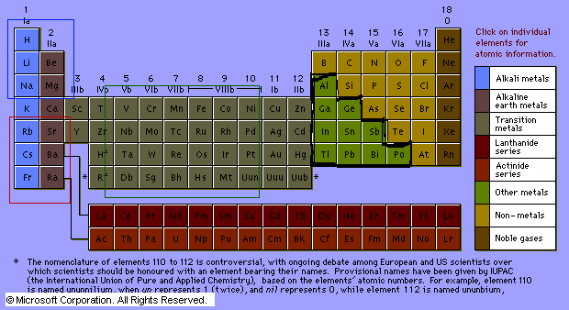

Here is the periodic table. As you can see I have done four selections. The red selection is the metals that react very violently and terefore will be high upp on the reactivity series. Francium has one electron has one electron. This means it wants to loose it, so when it gets the oppertunity it looses it and a reaction takes place. However in a atom the electrons are kept in their shells because of force. This makes it harder for the electrons close to the nucleus to brake free. But if we take Copper which has 11 outer electrons. It is easy for Copper to loose them but there are so many to loose so no reaction will take place.

In the blue section the metals react violently but not as much as the ones in the red section.

The green section covers many transmition metals. The transtition metals do not react very good because they ahave many outer electrons.

The black selection react even worse. This I do not know for a fact but I think so because they have so many outer electrons.

Different metals have different ways of reacting. In the way it looks anyway. Sodium reacts quickly with whizzling but calcium reacts slowly with some bubbles.

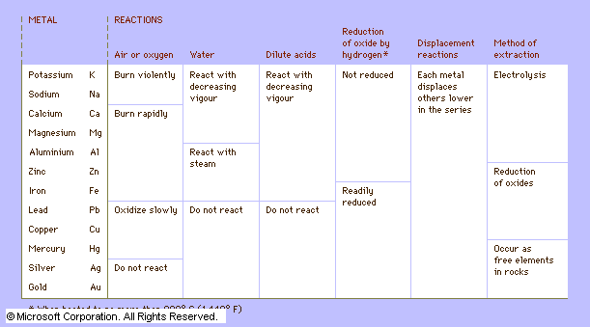

This is what the reactivity series table looks like. Several other versions exist too.

Discussion:

In daily life there are few reactions. At least that we can see or notice. Sometimes maybye there are reactions that we do not notice beacause they are so small.

Have you ever thought of just why jewlery is made of gold and silver, etc? Think if we would have a bracelet of magnesium. And we wnt out in the rain. Our hand would either dissapear or be damaged badly. The metals such as gold are called precious metals.

The reactivity seriers help workers or architects to decide what metale is good to use when building something. If you for example want to build a pansar truck, you do not build it out of Magnesium because there will be a reaction that will destroy the truck. Also think about Iron which reacts good with steam and hottness. We cannot biuld a hotwater tank out of Iron since it would not be there for so long time. Iron would be good to use in a cold water tank because no reaction would take place. Also imagine if coins where made out of Lithium. Then all of the coins would become destroyed.

Rust happens a lot. If you get water that is a metal solt sollution on a metal and it mixes with oxygen then a Iron hydroxide is formed. This is rust.

I hope that this labreport is better than my others. I have worked hard on it. However it is now 22:30 and i am a bit tired so you will probably find a couple of spelling miscackes, sorry I meant mistackes.

Eric Andersson

